DAY 15 - 30.04.2024 - QUERY OUTPUT SCREENSHOTS

SALES TABLE

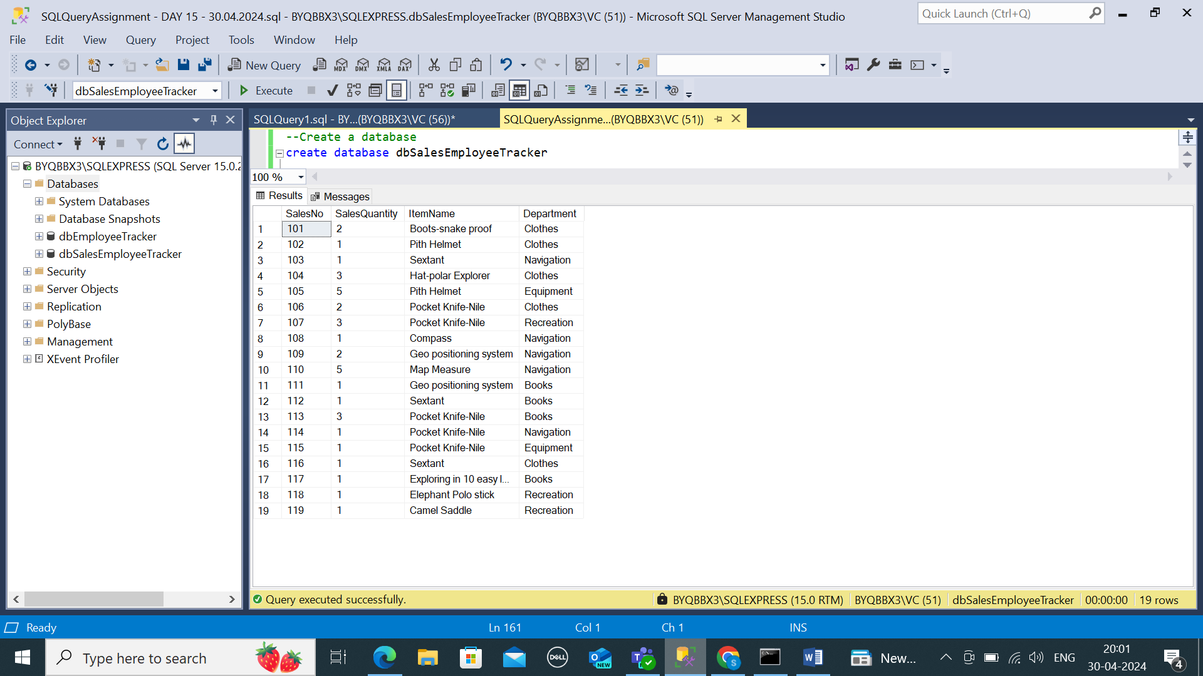

DEPARTMENT TABLE CREATION

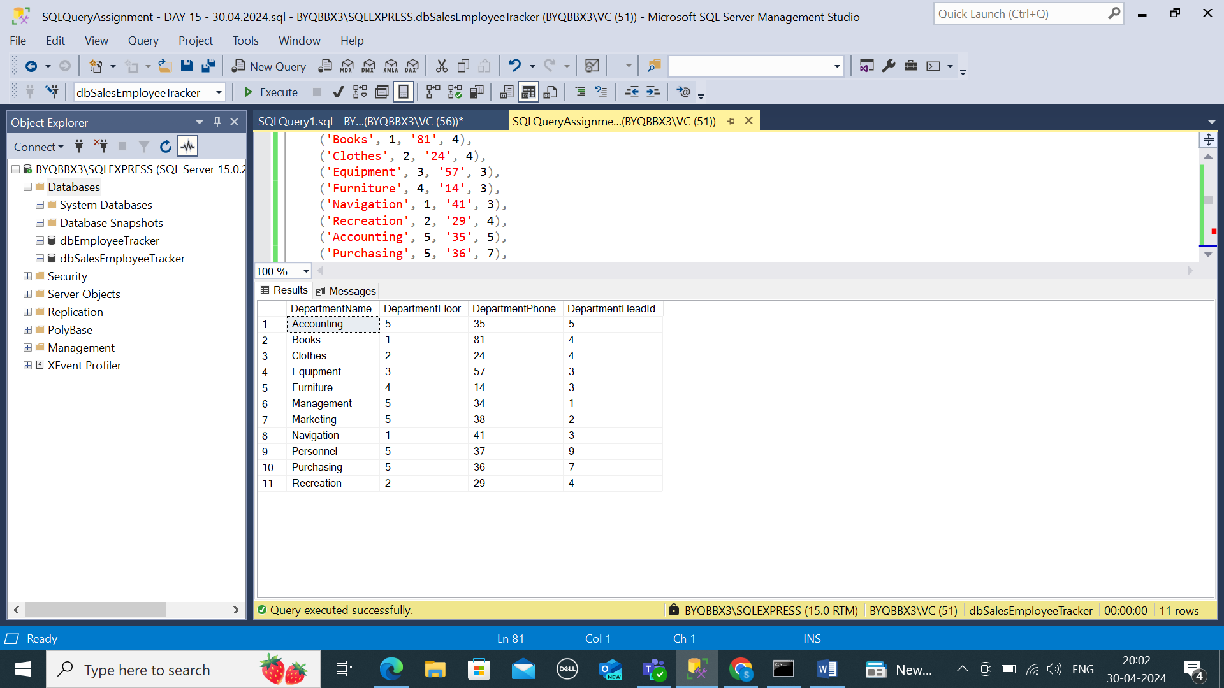

EMPLOYEE TABLE CREATION

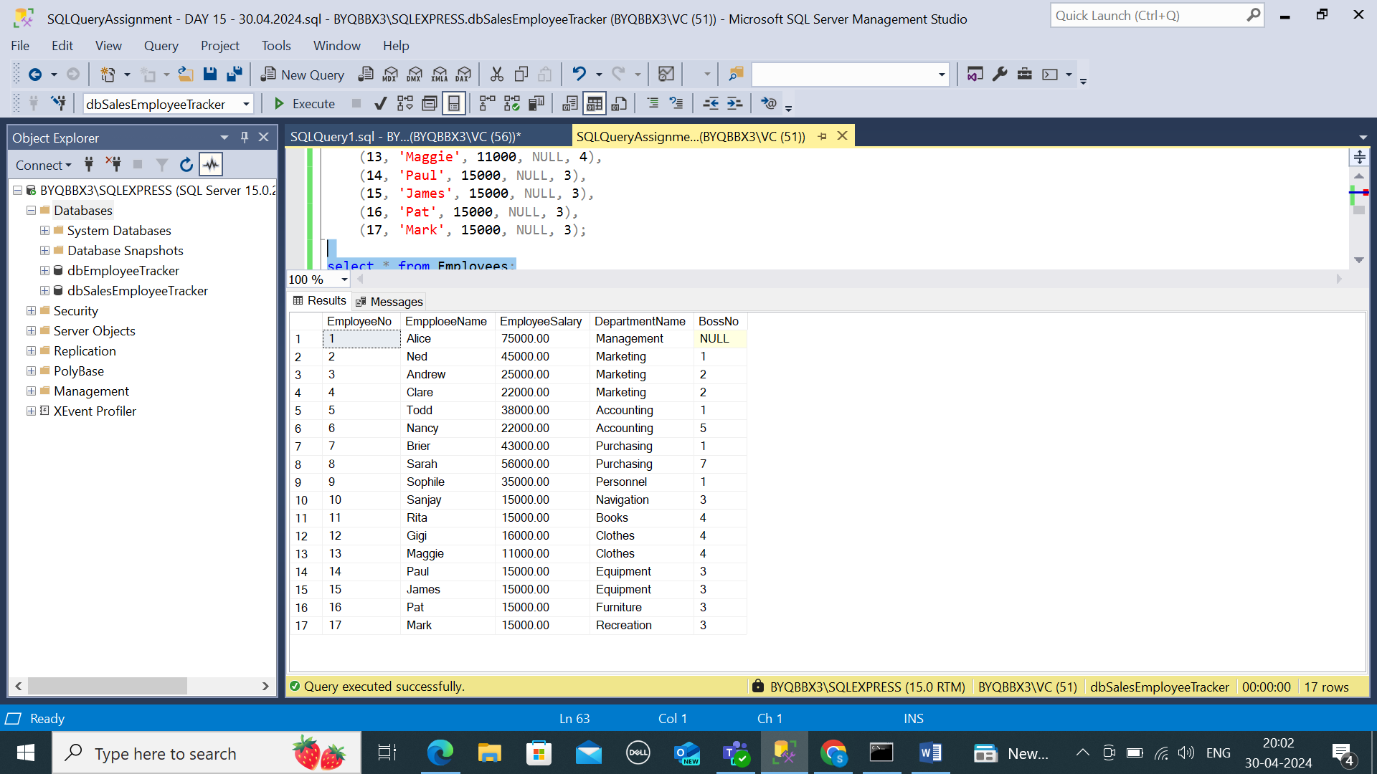

ITEM TABLE CREATION

